Kubernets
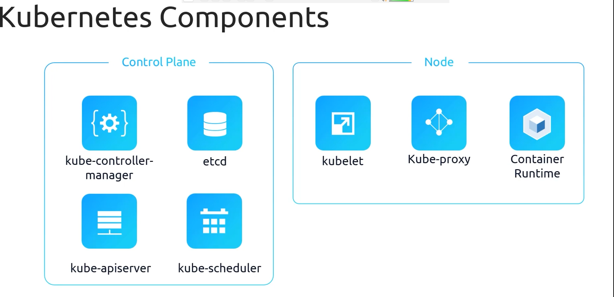
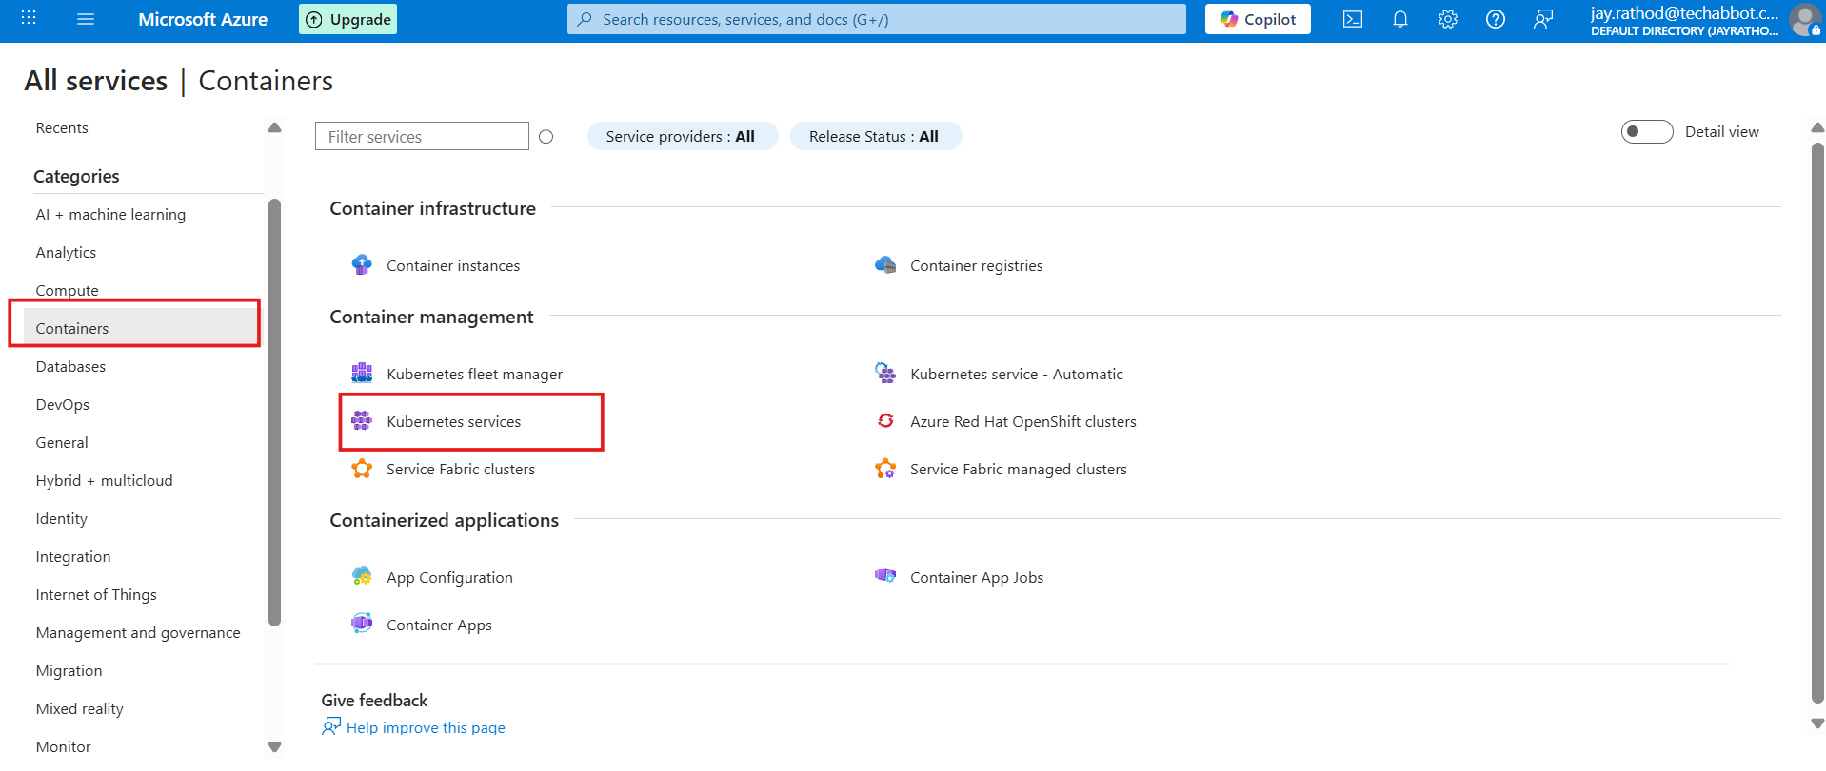
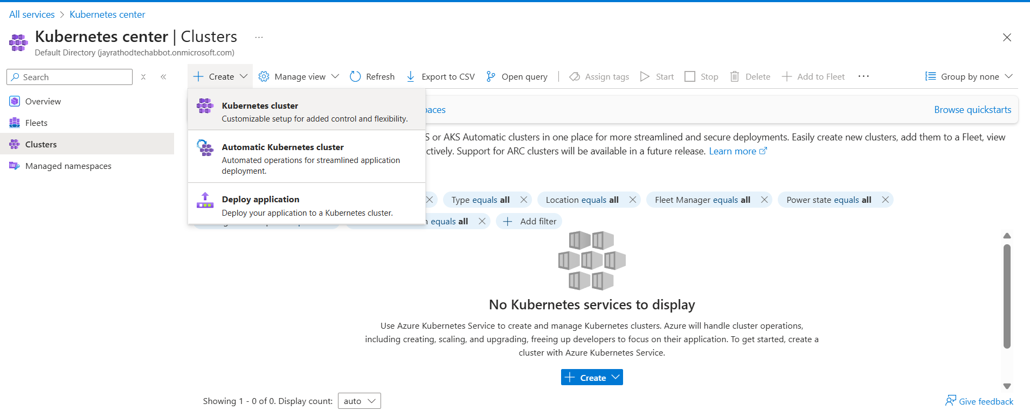
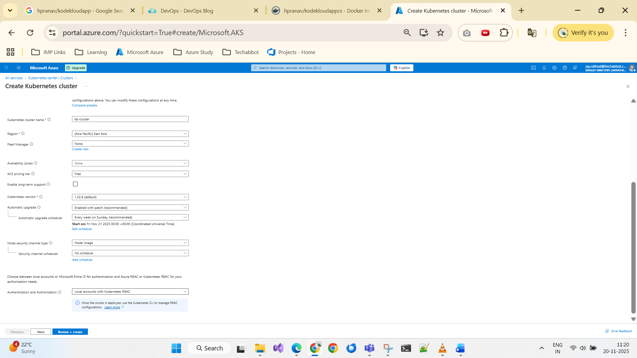
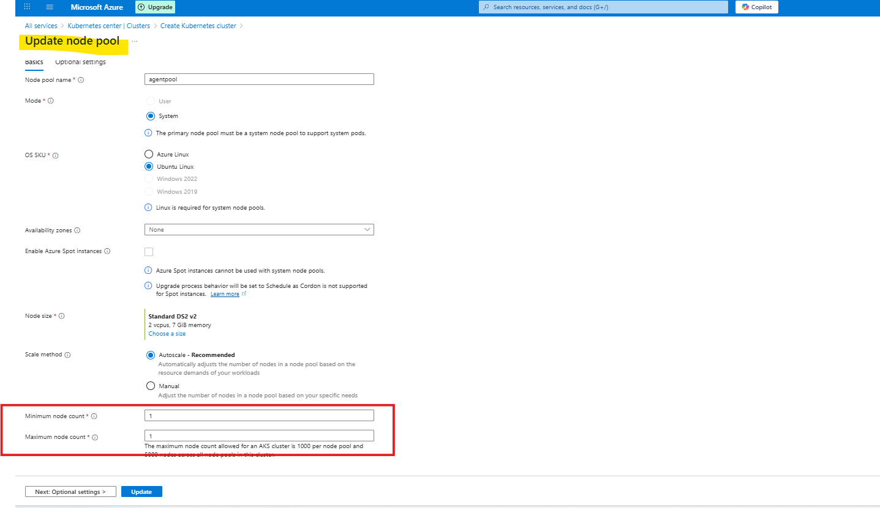
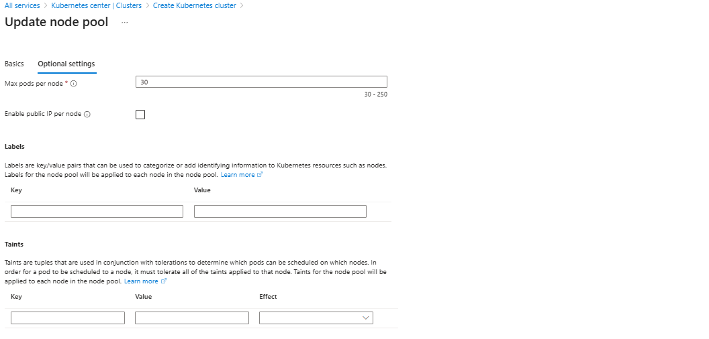
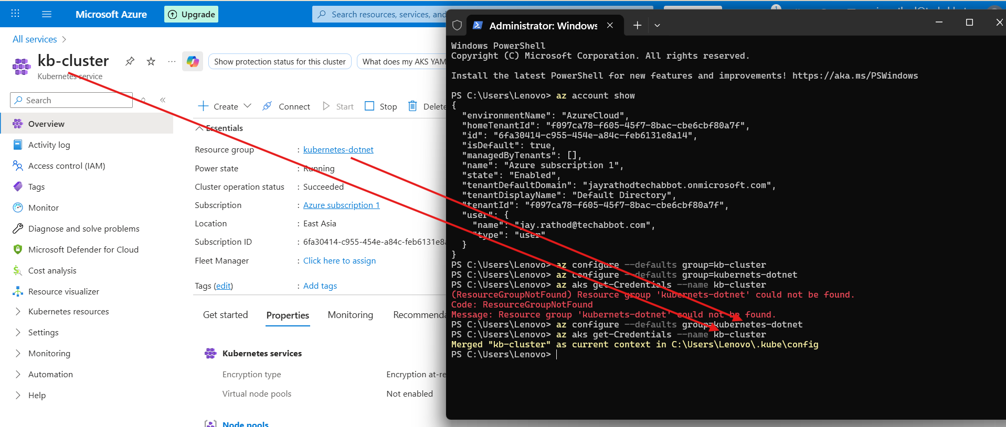
az configure --defaults group=kubernetes-dotnet
az aks get-Credentials --name kb-cluster
kubectl config current-context
(for verify)
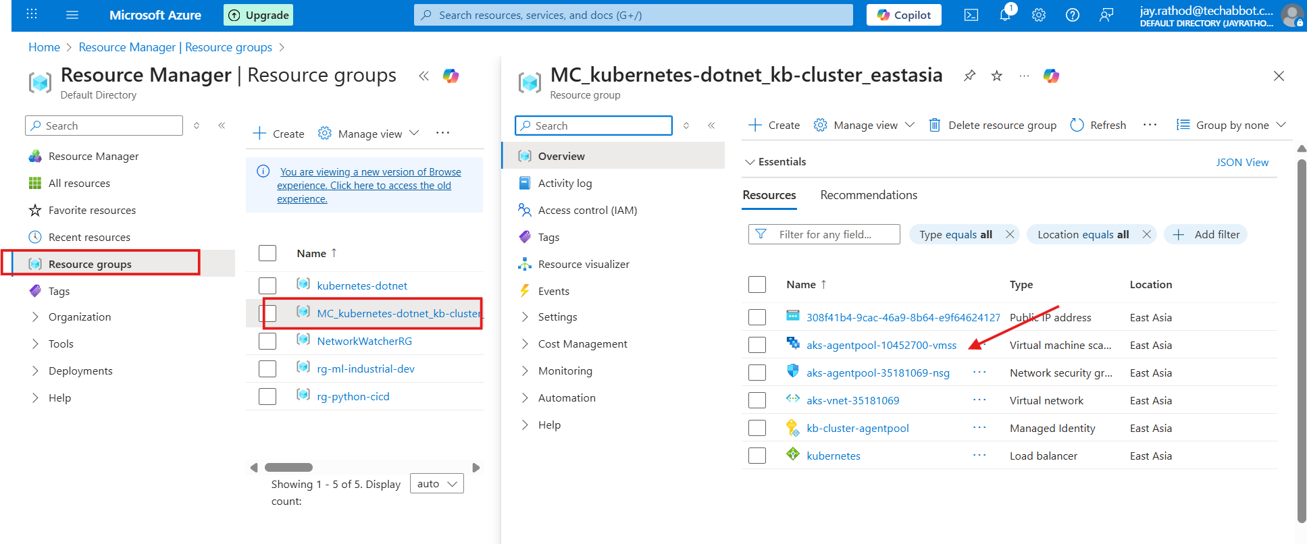
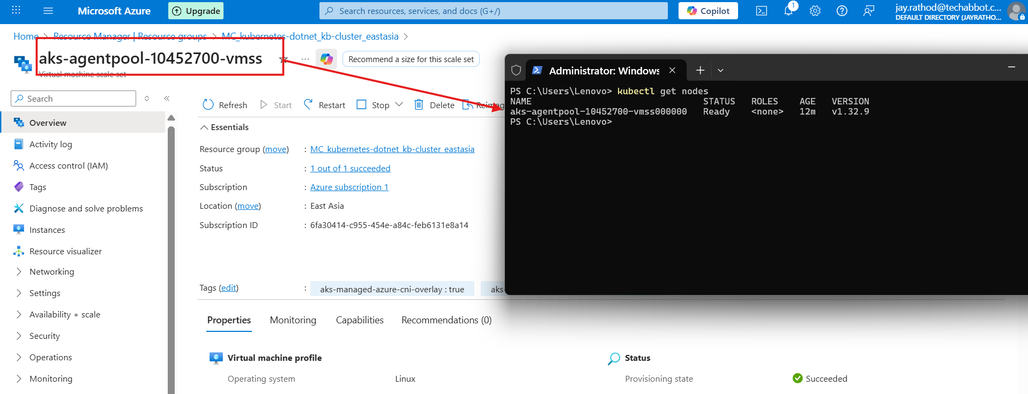
kubectl get nodes
kubectl get deployment
kubectl get pod

Upload the docker image

kubectl create deployment <jayrathodapp> --image=hpranav/kodekloudappcs:v1
Part of Command | Meaning
kubectl | CLI tool to interact with Kubernetes clusters
create deployment | Tells Kubernetes to create a Deployment (a controller that manages Pods and ensures desired state)
jayrathodapp | The name of the deployment
--image=hpranav/kodekloudappcs:v1 | The container image to use for the Pods (pulled from Docker Hub or container registry)

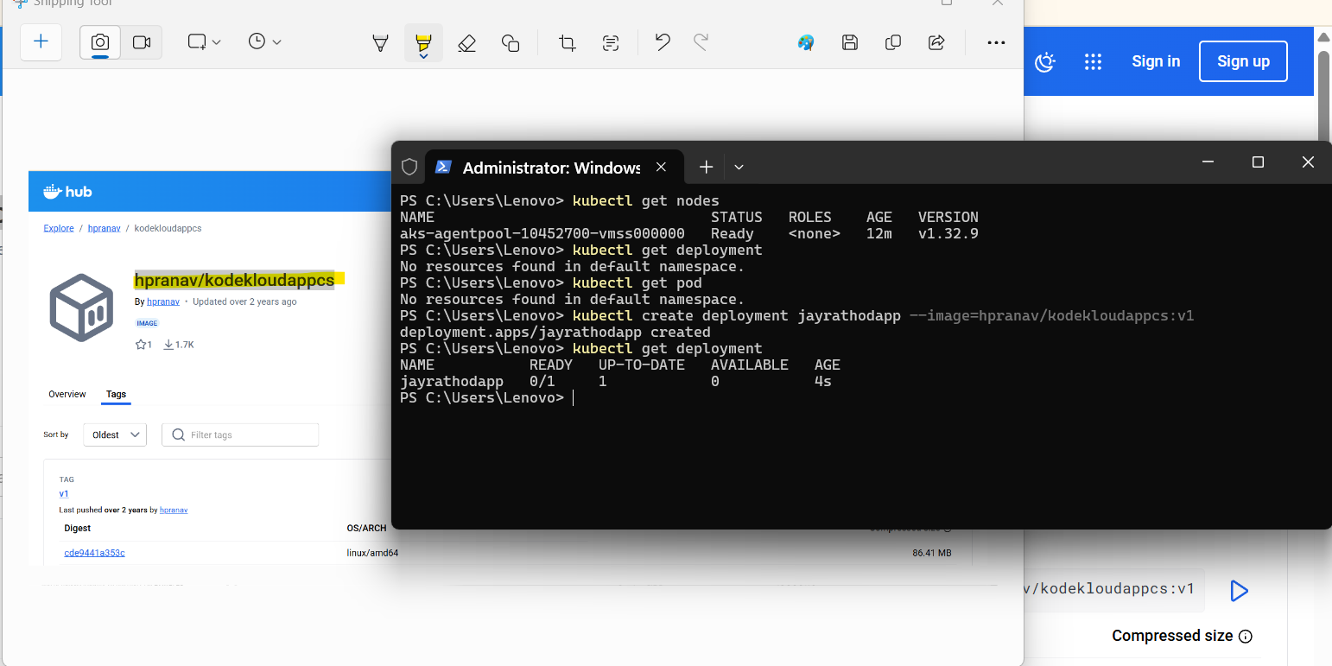
How to expose the deployment and run it

